**LEBANESE AMERICAN UNIVERSITY**

**USAID – HIGHER EDUCATION SCHOLARSHIP PROGRAM**

**HES - Volunteering Program Verification Form**

This form is to be used to document volunteering hours. If a student volunteers for multiple organizations, a separate form must be used for each organization. **This form must be turned in by the 28th of each month, the latest.**

I certify that the scholar Jana Walid Al Banna completed a total of 8 hours of service at Life Sculptor.

The hours were completed hours as per the below:

Hours # 0 (date) _30/09 – 5/10_ (initials of supervisor) __A.K.___

Hours # 0 (date) _7/10 – 11/10_ (initials of supervisor) __A.K.___

Hours # 4 date) _14/10 – 18/10 (initials of supervisor) __A.K.___

Hours # 4 date) _21/10 -25/10 (initials of supervisor) __A.K.___

Brief description of the activities the scholar performed or participated in:

Jana is the supervisor of will and wellness design. She assigns design tasks to volunteers to post them on social media.

Written feedback about the scholar’s performance:

Jana showcases outstanding leadership and project management skills, with a keen ability to organize, delegate, and guide teams efficiently. Her collaborative nature and proficiency in overseeing tasks highlight her talent for inspiring and managing others to achieve common objectives. Her sense of initiative and responsibility shines through as key strengths.

Please rate the overall performance of the scholar at your organization:

|  |  |  |  |
| --- | --- | --- | --- |
|  | Mastery (5) | Proficient (3) | Emerging (1) |
| **Problem solver** | X |  |  |
| **Engaged & Committed** | X |  |  |
| **Open-minded & multicultural** | X |  |  |

Signature

& stamp

__________________________

_

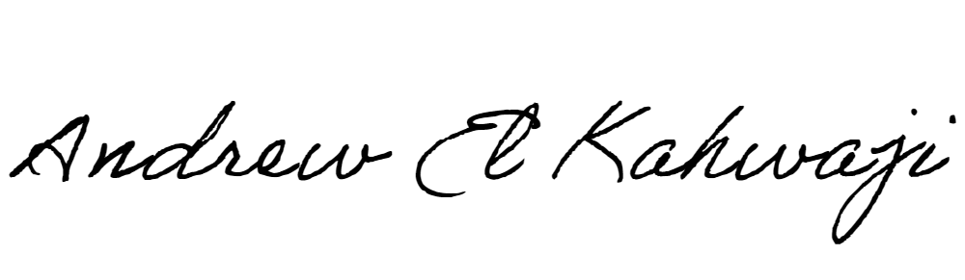

Printed Name _Andrew El Kahwaji_

Date __26/10/2024___

Email __andrew.lifesculptor.coo@gmail.com __

Phone __+961 71 914 378__

**LEBANESE AMERICAN UNIVERSITY**

**USAID – HIGHER EDUCATION SCHOLARSHIP PROGRAM**

